Create your own music video
Mission: The Image of Music
In this lesson, we can see the many benefits music brings us. Good music is like good medicine since it can soothe our spirits and minds. However, making a good music video (MV) is time-consuming and challenging. Do you understand the complicated process of producing a music video? In the following task, you will be guided to shoot your own MV with a step-by-step procedure.
Step 1. Checklist for Producing a Music Video
Brainstorm some important elements you need when shooting an MV in the pre-production, production, and post-production stages respectively.
Your ideas about the important elements of shooting an MV

Production Stage

Pre-production Stage

Post-production stage

參考答案：
Next, read the following two articles (see the external links) and discuss your answers with your partners.
What is said about MV production in the three different stages?
參考答案：  Pre-production Stage | 參考答案：  Production Stage | 參考答案：  Post-production Stage

Are there any similarities or differences with your original idea? What may be the biggest challenge for you when you decide to produce an MV? How would you overcome these challenges?

Step 2. Project Scheduling
On any big project, including making a music video, good planning is essential. The best approach is to break it down into manageable sections. Work Breakdown Structure charts are ideal for presenting your project to your team members and anyone else and can be very useful when allocating the tasks. Get into a team of 8-10. Choose an MV song that you like. Then finish the WBS charts together.
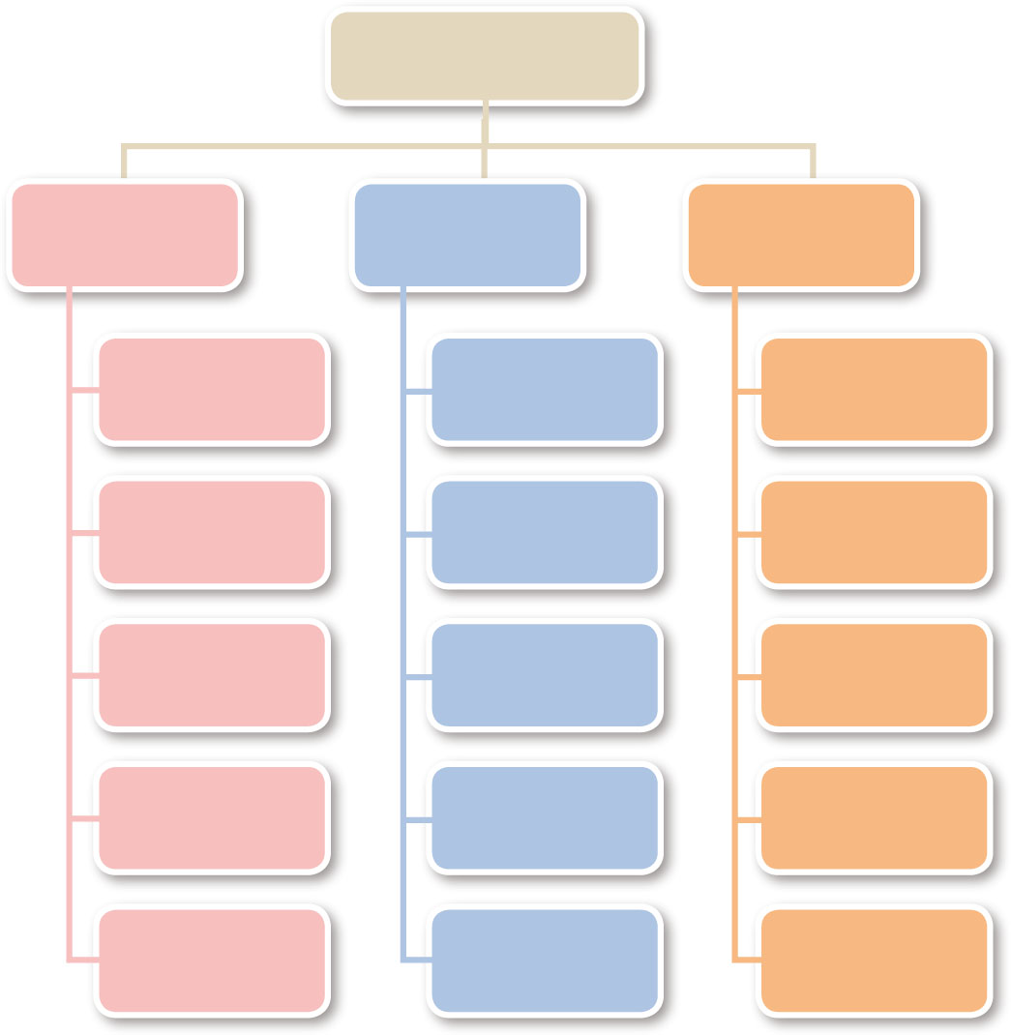
Shooting a Music Video
Pre-production Stage
Production
Stage
Post-production Stage
Choose a Song
Bring Equipment
Edit the video
Step 3. Create Your MV Storyboard
Once you have decided on the music, use a storyboard to analyze the song. You can use the following as a template to create your own storyboard. When analyzing the song, think about the four questions below.
1. What is the meaning behind the music video?
2. Who is/are the character(s) in the music video?
3. What might you hear in the music video?
4. What kind of costumes do you expect to see in the music video?
English Song:

Scene 1 Visual Image
Scene 2 Visual Image
Time:

Text (字幕) :

Shot/Montage (剪輯) :

Description:

Time:

Text ( 字幕) :

Shot/Montage ( 剪輯) :

Description:


Scene 3 Visual Image
Scene 4 Visual Image
Time:

Text (字幕) :

Shot/Montage (剪輯) :

Description:

Time:

Text ( 字幕) :

Shot/Montage ( 剪輯) :

Description:

Time:

Text ( 字幕) :

Shot/Montage ( 剪輯) :

Description:

Scene 5 Visual Image
Before Shooting the Video
After deciding who should play whom, check whether you have the necessary items, including props, equipment, costume, etc.

Character List

Props and Costumes
Equipment
Other Items

Step 4. 3, 2, 1 Camera … Action
After adequate preparation, it’s time for you to use the above storyboard and shoot the music video. Videotape your performance so that you can show it to your classmates.

